Brain Plugin Manual | FROG Recognizer of Gestures
Team Better Recognize
Version 1.0
April 1, 2010

Revision Sign-off
By signing the following, the team member asserts that he/she has read the entire document and has, to the best of his or her knowledge found the information contained herein to be accurate, relevant, and free of typographical error.

Name | Signature | Date
Josh Alvord
Alex Grosso
Jose Marquez
Sneha Popley
Phillip Stromberg
Ford Wesner

Revision History
The following is a history of revisions of this document.

Document Version | Date Edited | Changes
Version 1.0 | 04/01/10 | Initial Draft

Table of Contents
Revision Sign-off i
Revision History ii
1. Introduction 4
1.1 Purpose 4
1.2 Scope 4
1.3 Definition of Terms 4
2. Preparations 5
2.1 Necessary Head Preparation 5
2.1.1 Shaving the Head 5
2.2 Setting the Correct Variables 6
3. Attach Device Firmly to Head 7
4. Using Your Brain with FROG 8

Introduction

Purpose
This document serves to outline the basic installation and use of the brain plug-in with the FROG Recognizer of Gestures program. The entire set up process including where to place nerve contacts and where to drill the skull holes is covered in this manual.

Scope
This document will be useful for both users and developers for FROG. Anatomy of the brain will not be covered here and it is assumed the reader is well-schooled in neurology, electrical engineering, and power tools.

Definition of Terms
Aneurysm | A burst blood vessel. Aneurysms can be fatal depending on their severity. When using the FROG Recognizer of Gestures’ brain plugin, avoid prolong exposure to the brain contacts as these have been shown to cause aneurysms.

Preparations

Necessary Head Preparation
Whether you will be developing with the brain plugin or just using it with FROG, you will need a brain driver to deploy the FROG code to your brain and more.

Shaving the Head
Ensure you have shaved your head first. It can be very messy to drill into a skull that still has hair on it, as the hairs can get all caught up in the drill bit and cause it to short out. Also it hurts.
Figure 2-1: Properly shaved head

Setting the Correct Variables
Additionally, the variable HUMAN_BRAIN must be set to ensure proper connection. You may experience extreme discomfort, confusion, and urges to mate with inanimate objects if you choose MONKEY_BRAIN or DOG_BRAIN.
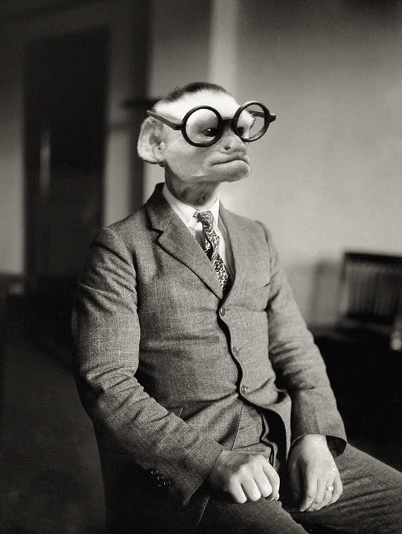
Figure 2-2: Ill effects of leaving MONKEY_BRAIN variable set to true

Attach Device Firmly to Head
Before you can begin using your brain with FROG, the brain must have the special FROG brain hat attached and running first. Thanks to super glue, the process of attaching the device is much easier.
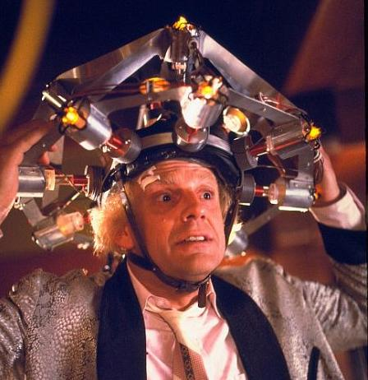
Figure 3-1: Properly attached FROG Brain Hat (patent pending)

Using Your Brain with FROG
Before attempting to use a brain with FROG ensure that the FROG code has been deployed to the brain and a brain receptor is connected to the computer that will be running FROG. Once these two essentials are complete it is simply a matter of starting up FROG and finding your brain. Launch FROG to begin the process of connecting your brain.
Connecting a brain to FROG is done by simply bringing up the Device Connection and Set Up menu shown in Figure 4-1. Simply hit Discover to find brains in your immediate area.

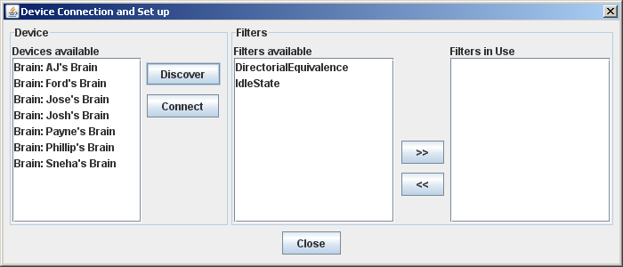
Figure 4-1: Connecting to a Brain

From here on out, simply think about the shape you wish to make and FROG will capture and store the pattern of your brain waves. In recognition mode, you can think of the same shape and FROG will do a bunch of math stuff to your brain waves to figure out which new shape you thought of. Neat!

